Chapter 11, Solution 8.

We apply nodal analysis to the following circuit.
40 
j10 
0.5 I_{o}
60 A
V₁
V₂
I_{o}
I₂
-j20 

At node 1,
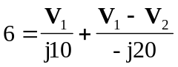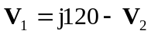 (1)
At node 2,
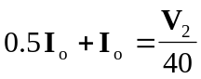
But, 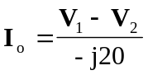
Hence, 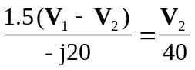
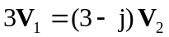 (2)

Substituting (1) into (2),
